Table Schema

DDL:

create database dbDDLSchema

use dbDDLSchema

create table Employees

(emp_no int identity(1,50) constraint sc_emp_no primary key,

emp_name varchar(40),

emp_salary varchar(20),

depart_name varchar(50) null,

boss_no int null constraint dc_emp_no foreign key references Employees(emp_no))

sp_help Employees

create table Department

(dept_name varchar(20) constraint sc_dept_name primary key,

dept_floor int,

dept_phone char(2),

emp_no int not null constraint fc_emp_no foreign key references Employees(emp_no))

sp_help Department

alter table Employees

add dept_name varchar(20) null constraint fc_dept_name foreign key references Department(dept_name)

sp_help Employees

alter table Employees

drop column depart_name

sp_help Employees

create table Item

(item_name varchar(30) constraint sc_item_name primary key,

item_type char(1),

item_color varchar(20))

sp_help Item

create table Sales

(sales_no int identity(101,200) constraint sc_sales_no primary key,

sale_qty int,

item_name varchar(30) not null constraint dc_item_name references item(item_name),

dept_name varchar(20) not null constraint dc_dept_name references department(dept_name))

sp_help Sales

DATABASE DIAGRAM:

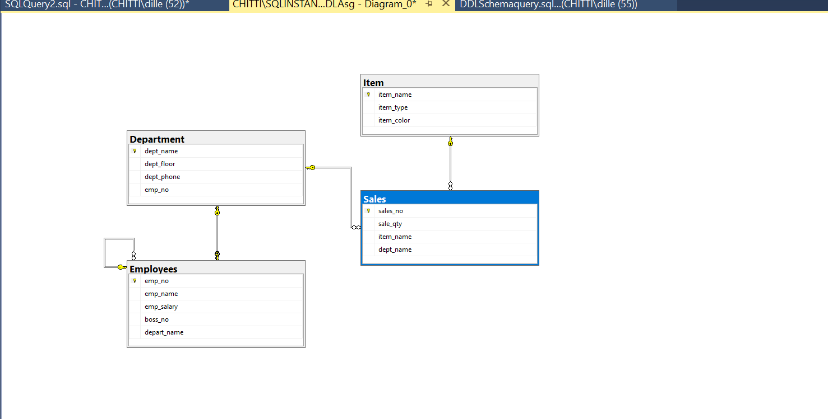

DML:

--Insertion query

insert into item(item_name, item_type,item_color) values('Pocket Knife-Nile', 'E', 'Brown')

insert into item(item_name, item_type,item_color) values('Pocket Knife-Avon', 'E', 'Brown')

insert into item(item_name, item_type,item_color) values('Compass', 'N', NULL)

insert into item(item_name, item_type,item_color) values('Geo positioning system', 'N', NULL)

insert into item(item_name, item_type,item_color) values('Elephant Polo stick', 'R', 'Bamboo')

insert into item(item_name, item_type,item_color) values('Camel Saddle', 'R', 'Brown')

insert into item(item_name, item_type,item_color) values('Sextant', 'N', NULL)

insert into item(item_name, item_type,item_color) values('Map Measure', 'N', NULL)

insert into item(item_name, item_type,item_color) values('Boots-snake proof', 'C', 'Green')

insert into item(item_name, item_type,item_color) values('Pith Helmet', 'C', 'Khaki')

insert into item(item_name, item_type,item_color) values('Hat-polar Explorer', 'C', 'White')

insert into item(item_name, item_type,item_color) values('Exploring in 10 Easy Lessons', 'B', NULL)

insert into item(item_name, item_type,item_color) values('Hammock', 'F', 'Khaki')

insert into item(item_name, item_type,item_color) values('How to win Foreign Friends', 'B', NULL)

insert into item(item_name, item_type,item_color) values('Map case', 'E', 'Brown')

insert into item(item_name, item_type,item_color) values('Safari Chair', 'F', 'Khaki')

insert into item(item_name, item_type,item_color) values('Safari cooking kit', 'F', 'Khaki')

insert into item(item_name, item_type,item_color) values('Stetson', 'C', 'Black')

insert into item(item_name, item_type,item_color) values('Tent - 2 person', 'F', 'Khaki')

insert into item(item_name, item_type,item_color) values('Tent -8 person', 'F', 'Khaki')

select * from item

insert into sales values('2', 'Boots-snake proof', 'Clothes')

select * from sales

insert into Employees(emp_name,emp_salary,boss_no,dept_name) values('Alice','75000', NULL,'Management')

select * from Employees

insert into Department(dept_name,dept_floor,dept_phone,emp_no) values('Management', '5', '34', '1')

select * from Department

updation query

deletion query

***while executing sales or employees or department after insertion I’m getting error continuously mam I’m not getting where I have done mistake…please have a look at this and let me know my error***